**Ganpat University**

**Faculty of Engineering & Technology**

**Computer Science & Engineering**

***Name:- Dwij Vatsal Desai***

***Sem:- 2***

***Sub: - BOSS***

***Enrollment No.:- 23162121027***

***Prac:- 11***

***Date:- 20/4/2024***

**Practical 11**

1. List the configurations files related to openssh-clients and openssh-server

***Command:-***

rpm -q --configfiles openssh-clients

rpm -q --configfiles openssh-server

***Image:-***

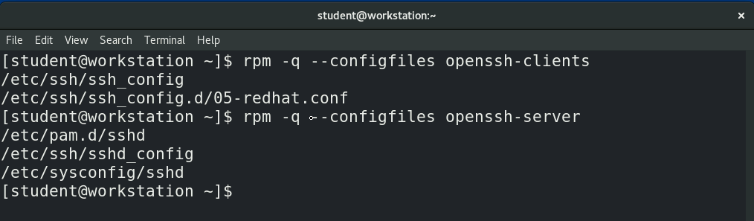

1. List all the information related to gedit package.

***Command:-***

rpm -qi gedit

***Image:-***

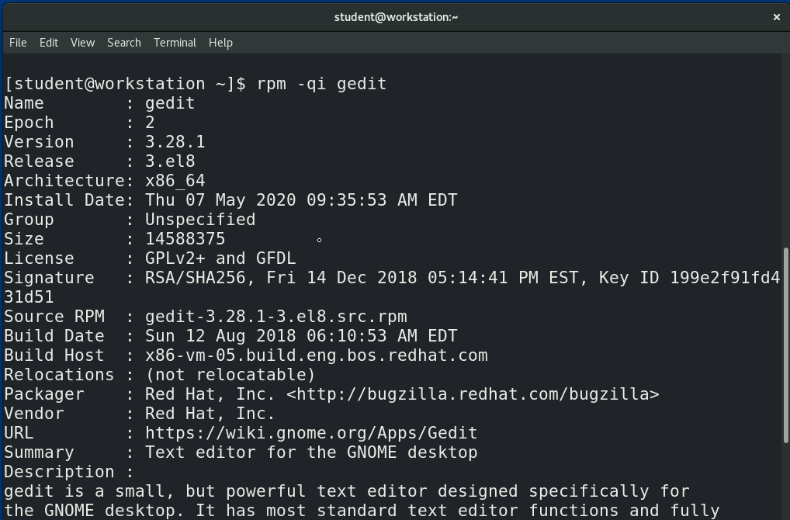

1. List all the packages installed on your system.

***Command:-***

rpm -qa

***Image:-***

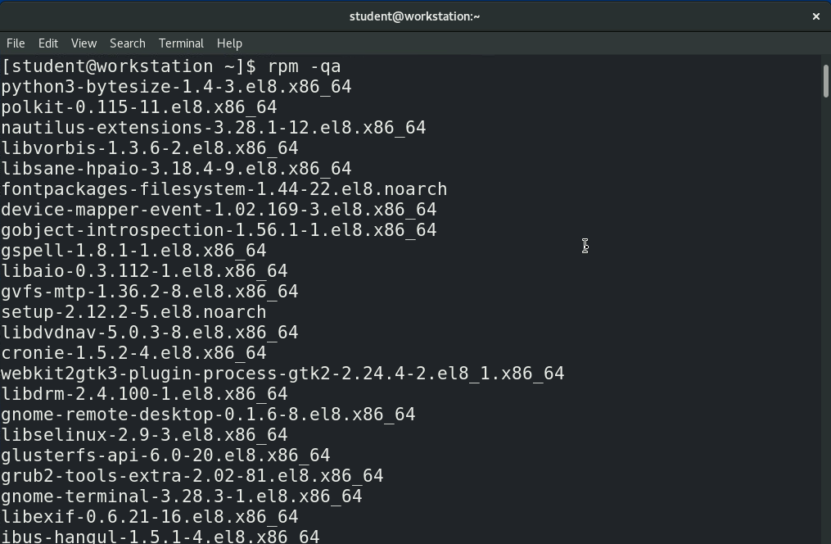

* **From here on out,**

**Using yum to perform following tasks:**

1. Install Apache server in your system and verify whether it is installed correctly or not.

***Command:-***

sudo yum install httpd

httpd -v

***Image:-***

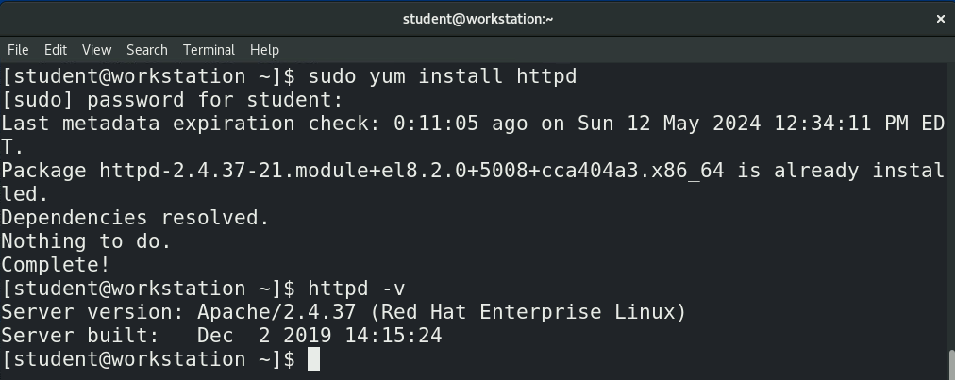

1. Create a directory with **your_name** at appropriate location and access the same from localhost.

***Command:-***

sudo mkdir /var/www/html/DWij

sudo vi /var/www/html/DWij/index.html

sudo chown -R apache:apache /var/www/html/DWij

sudo systemctl start httpd

sudo systemctl enable httpd

in index.html:-

<html>

<body>

<h1> Hellooo from techno </h1>

</body>

</html>

***Image:-***

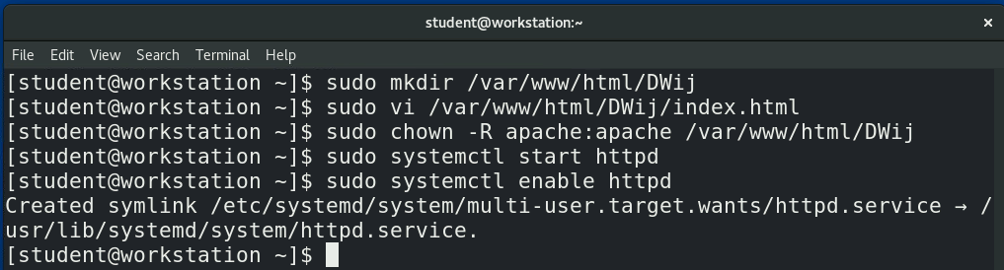

***HTML code:-***

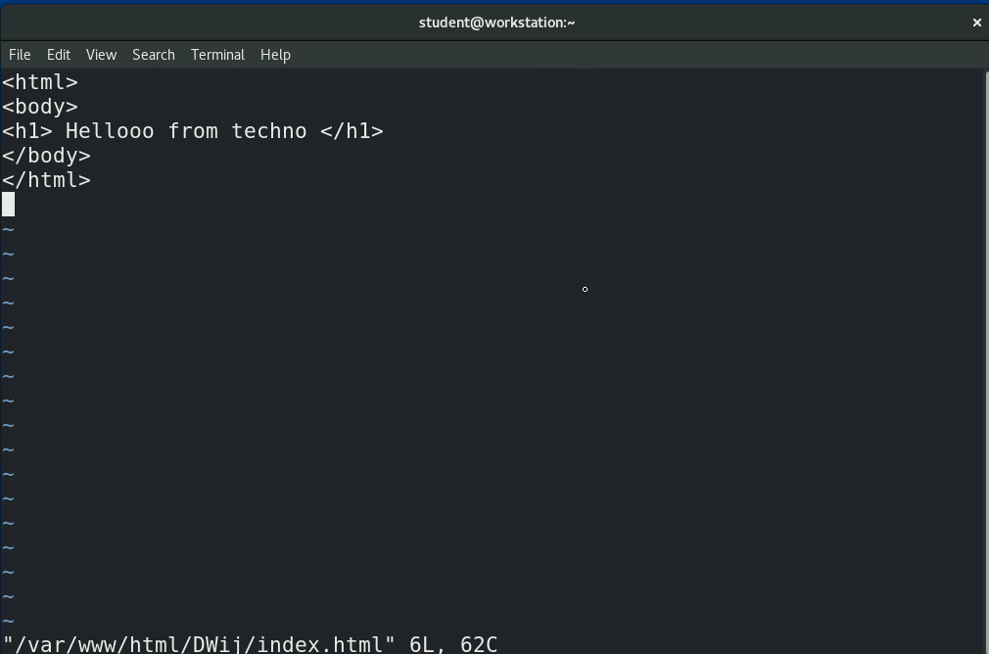

***Final Output:-***

